The Story Behind the Criterion:

Economy

Just Transitions in the Delta: Drought, Sea-Level Rise, and Salinity
University of California Multicampus Research Programs and Initiatives

Prepared by
Yu Cai
Josue Medellin-Azuara

University of California, Merced
September, 2026

What is the criterion: Economy 3
Definitions 3
Why does this criterion matter? 3
How was this criterion constructed? 3
What are the components of this criterion? 4
Subregional Map 4
Metric: Gross Revenue Change 6
Location of Measurement 6
Methods 6
Results 7
Adaptation Scenario Analysis 7
Salinity-only scenarios: Business As Usual, A Tunnel, Calling on Reserves, Bolster and Fortify 7
New Green Watershed 8
Carbon Revenue Quantified 10
Eco Machine 11
Metric: Employment Change 11
Location of Measurement 11
Methods 11
Results 12
Adaptation Scenario Analysis 12
Metric: Value Added Change 14
Location of Measurement 14
Methods 14
Results 14
Adaptation Scenario Analysis 14
Comparative Scenario Performance Ranking 16
Implications and Discussion 17
References 19

What is the criterion: Economy

Definitions
This criterion asks a simple question: when the Delta's water gets saltier, or when land gets converted from farming to something else, what happens to the Delta's economy? We track that in three ways: how much money Delta farms bring in from selling what they grow (Gross Revenue), how many jobs depend on that activity plus the businesses tied to it (Employment), and how much that activity adds to the regional economy once wages and business income are counted (Value Added).

Why does this criterion matter?
The Delta supports a working economy: close to 500,000 acres of irrigated farmland, plus the packing houses, equipment dealers, and trucking that depend on it, plus tourism and recreation on the water. Every one of the six futures this study considers touches that economy somehow — some through salt water reaching farm fields, others by converting farmland to wetland outright. Tracking the economic size of those effects, and where they land, is a basic way to compare the futures against each other.

In lay terms: people care about this criterion because it eventually shows up as someone's paycheck or a farm's bottom line. It's also one of the few criteria where the actual dollar and job effects, at least from salinity alone, turn out to be very small relative to a billion-dollar economy — a genuinely reassuring finding, detailed below.

How was this criterion constructed?
Two very different modeling chains feed this criterion, because the six scenarios do two very different things to the Delta economy. Four scenarios (Business As Usual, A Tunnel (pending estimations), Calling on Reserves, Bolster and Fortify) mainly change water salinity, which can reduce crop yields — that effect was modeled by running a hydrodynamic salinity simulation through a crop-yield-loss model and a regional agricultural production model (OpenAg), then through IMPLAN, a standard regional economic model, to get jobs and value added. New Green Watershed goes further: it converts subsided Delta farmland itself to wetland, rice, or paludiculture at three restoration intensities, which removes that land's revenue outright regardless of salinity. That land-use effect was modeled separately by Cai et al. in a manuscript in preparation — the DAP basecase's official Delta-wide crop acreage and revenue data, matched island-by-island to each restoration level's footprint, adjusted into a modified regional economic base case, and then run through IMPLAN directly to get Direct and Total (regional-multiplier) Revenue, Employment, and Value Added effects for all three restoration levels. Eco Machine's own land conversion (Suisun Marsh and the Franks Tract Futures’ design) was estimated separately: farm revenue lost on the converted land (from DWR’s 2024 land use and corresponding OpenAg revenue per acre), jobs and value added from the same IMPLAN ratios and multipliers as the New Green Watershed runs, carbon offset revenue from the Delta Island Adaptation greenhouse-gas rates, and one-time construction cost. It was not run through IMPLAN directly, but so little of the island is farmed that dia direct run through is unlikely to change the scenario score.

What are the components of this criterion?

Three metrics are scored for every scenario:
● Gross Revenue Change — the change in total dollar sales from Delta farms.
● Employment Change — the change in full- and part-time jobs tied to that farm activity, directly and through supporting businesses.
● Value Added Change — the change in wages, business income, and taxes generated once that revenue works its way through the regional economy (approximately the change in regional GDP).

Two further indicators — Applied Water Use Change and Land Use Change — are tracked narratively rather than scored on their own, since they are the mechanism behind the three scored metrics rather than separate economic outcomes.

Subregional Map
Below is a map showing land use in the Legal Delta in 2024, using Land Use information from the Department of Water Resources ( (https://data.cnra.ca.gov/dataset/statewide-crop-mapping )

We subdivided the Legal delta into four subregions, three of them delimited by water agency (North, Central, and South Delta Water Agencies), and one section west of the Delta. Suisun Marsh lies outside of these four subregions, its land use from CDFW 2021 vegetation survey and 2024 DWR crop mapping) is used for the EcoMachine land-use estimate described below.

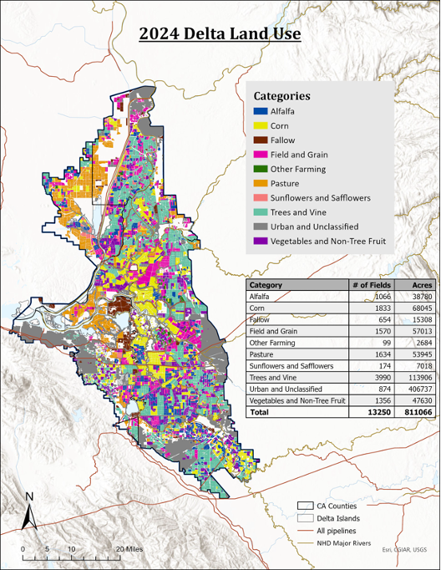

Because a Delta-wide total can hide a lot — some islands gain under a scenario that looks neutral overall, others lose — this criterion also reports results by four Delta zones (North, Central, West, South), shown below for one metric as an example.

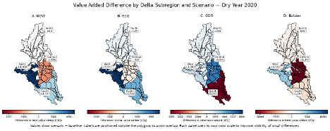
Example subregional breakdown: change in Value Added by Delta zone and scenario, dry year 2020, salinity-only pathway (New Green Watershed's land-use effect is reported separately, since it is not from this same salinity model run).

Metric: Gross Revenue Change

Location of Measurement
Salinity-driven effects are measured Delta-wide and by the four Delta zones (North, Central, West, South), using the same OpenAg regional agricultural model areas as the manuscript's wet-year (2019) and dry-year (2020) runs. New Green Watershed's land-use effect is measured island-by-island using the DAP basecase's official Delta-wide crop acreage and revenue data, matched to its three restoration footprints, then summed Delta-wide and by zone (see the regional table under Results).

Methods
What we are measuring (or estimating): total dollar sales from Delta agriculture (gross revenue), and how it changes under each scenario relative to doing nothing (Business As Usual).
Origin of data: Business As Usual (Baseline), A Tunnel, Eco Machine, New Green Watershed (0.25MW / 0.5MW / Full MW), Calling on Reserves, Bolster and Fortify.

Origin of data:
Datasets: Agricultural land use and value were obtained from the OpenAg model at http://OpenAg.ucmerced.edu , which contains land use information from DWR.
Tiered Outflows: (not shown in the present analysis).
- Historic Baseline
- 30% outflow increase from baseline
- 10% outflow decrease from baseline

Adaptation Scenarios:
- Business As Usual (Baseline)
- A Tunnel (In process)
- Eco Machine
- New Green Watershed (Low 0.25 MW, Medium 0.5 MW, and full restoration).
- Calling on Reserves
- Bolster and Fortify

Unit of measurement: In 2024 US Dollars, annualized.

Where are we measuring: the entire Delta and by the four Delta zones.

Results

Adaptation Scenario Analysis
Two very different stories sit inside this metric, so these are discussed separately.

Salinity-only scenarios: Business As Usual, A Tunnel (Pending), Calling on Reserves, Bolster and Fortify
Delta agriculture represents roughly $1.1 billion in annual economic activity, and none of these four scenarios changes that total by more than a small fraction of one percent. Across both wet and dry years, the RMA-modeled salinity fluctuations produce only modest changes in crop yields and associated agricultural value. The resulting economic effects are therefore real but small—at most a few hundred thousand dollars relative to a billion-dollar agricultural economy. Given the small magnitude of these differences, results are reported as changes in dollar value and relative differences among scenarios rather than as percentages carried to multiple decimal places, which could imply a level of economic significance that the results do not support.
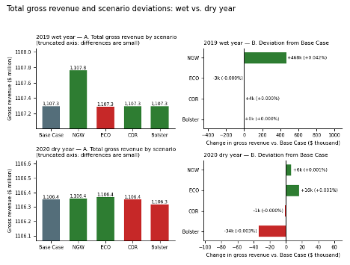
Total farm revenue by scenario, compared to doing nothing — wet year (top) and dry year (bottom).
In a dry year, Bolster and Fortify is the only one of these scenarios that reduces Delta farm revenue, about $34,000 less than the BAU., mostly in the Central Delta. Calling on Reserves is close to neutral. None of these three scenarios (a tunnel pending), comes anywhere near the scale of what happens under New Green Watershed, described next.In lay terms: of these four scenarios, Bolster and Fortify is the weakest performer in a dry year, and Calling on Reserves is close to neutral in most years; the same pattern shows up in jobs and value added below, in every case the change a fraction of a percentage point, consistent with previous findings in regard to modeled salinity and crop yield response in the Delta (Medellin-Azuara et al. 2012)

New Green Watershed
New Green Watershed converts subsided Delta farmland to a mix of managed and floating wetlands, rice, and paludiculture, at three possible intensities — full restoration (all targeted farmland converted, labeled Full MW), medium restoration (roughly half to wetland, half to rice, labeled 0.5MW), and low restoration (roughly a quarter to wetland, three-quarters to rice, labeled 0.25MW). Every island in the footprint is flagged either MW (managed wetland — all of its agricultural acreage and revenue is retired) or R (rice — it stays in agricultural production but switches to rice, at the Delta's average rice rate of about $1,827 per acre gross, $109 per acre net). Which islands are MW versus R, and how that mix shifts as restoration scales up, is set island-by-island; several islands that stay in rice at 0.25MW or 0.5MW convert to managed wetland once restoration reaches Full MW.
Using the DAP basecase's official Delta-wide crop acreage and revenue data, matched island-by-island to each restoration footprint, here is what full, medium, and low restoration do to on-farm revenue:
Restoration level | Acres to managed wetland (MW) | Acres converted to rice (R) | Gross revenue change
Full MW (all farmland out) | 207,000 ac | 0 ac | –$504.5M/yr (–45.6%)
0.5MW (~50% wetland, ~50% rice) | 85,500 ac | 121,500 ac | –$282.5M/yr (–25.5%)
0.25MW (~25% wetland, ~75% rice) | 48,200 ac | 156,700 ac | –$212.4M/yr (–19.2%)
Note: Source: Just Transitions AC meeting DAP basecase (432,547 baseline acres, total revenues were set at $1.6 billion, but that included a multiplier effect over the direct $1,107.3M baseline gross revenue)
The IMPLAN model reports two concepts worth telling apart: Direct effects are the on-farm/on-island activity itself — the same gross revenue figures above, plus the wages and jobs tied directly to farming that land. Total effects add IMPLAN's regional multiplier — the follow-on activity at supporting businesses (indirect) and from household spending (induced) as that farm income circulates through the regional economy. Delta-wide, the total-to-direct multiplier runs approximately 1.48× for revenue, 1.49× for value added, and 1.54× for jobs (jobs multiply by more because a dollar of indirect and induced spending tends to support more, lower-wage positions than a dollar of on-farm revenue does). Both are reported below — Direct where the on-farm loss itself is the number that matters, Total where the region-wide ripple effect is:

Restoration level | Direct revenue, adjusted | Direct change | Total revenue, adjusted | Total change
Full Managed Wetland (MW) | $602.8M/yr | –$504.5M/yr (–45.6%) | $884.7M/yr | –$747.3M/yr (–45.8%)
0.5 MW | $824.8M/yr | –$282.5M/yr (–25.5%) | $1,202.8M/yr | –$429.2M/yr (–26.3%)
0.25 MW | $894.8M/yr | –$212.4M/yr (–19.2%) | $1,303.4M/yr | –$328.6M/yr (–20.1%)
Note: Baseline: Direct $1,107.3M/yr, Total $1,632.0M/yr. Direct figures are the same on-farm gross revenue figures shown in the table above; Total figures add IMPLAN regional economic multipliers which factor in the spillover effects of each scenario.
The New Green Watershed also includes Eco Machine's restoration in Suisun Marsh and Franks Tract. Adding Eco Machine at the matching scale (a quarter, half, or all of the restorable Suisun land) adds only $0.3–1.2M/yr to the direct revenue loss, giving –$212.7M/yr (0.25MW), –$283.1M/yr (0.5MW) and –$505.6M/yr (Full MW), so the percentages above do not change. Its larger effects are on carbon revenue and construction cost, described below. Including Eco Machine and the rice conversion, one-time construction for New Green Watershed is about $1.2 billion (0.25MW), $1.5 billion (0.5MW) and $2.1 billion (Full MW), of which Eco Machine accounts for 71–74%.

Carbon Revenue Quantified
Wetland and rice both emit far less peat-soil carbon than the corn cropland they replace, so converted acres can generate carbon-offset revenue. Using the DIA project's per-hectare greenhouse-gas rates (corn as the baseline crop, wetland and rice as the replacement), the DIA study’s conservative carbon price of $15/tCO2e (Deverel et al. in press), and a 14% discount for market and verification risk, converted land earns approximately $165 per acre per year as wetland, or $86 per acre per year as rice (Deverel et al. In Press).

Restoration level | Carbon-offset revenue (annual) | Share of revenue loss offset
Full MW | $34.2M/yr | 7%
0.5MW | $24.7M/yr | 9%
0.25MW | $21.5M/yr | 10%

In lay terms: carbon-offset revenue is real, and closes a meaningful minority of the revenue gap — roughly 7-10%, with a larger share at lower restoration intensities. That's not because carbon revenue itself is bigger there — it's because at 0.25MW and 0.5MW, most of the converted acreage stays in production as rice rather than going fully idle as wetland, so the gross revenue lost per acre is smaller, and the same carbon credit covers a bigger share of a smaller gap. It is a genuine partial offset, not a rescue, The figure uses the DIA study’s conservative price of $15/tCO2e with its 14% risk deduction and a corn baseline at the midpoint of the DIA emission range. Current prices are probably higher, uncertainty in the DIA study of 10% would lower the offset by about the same rate.
Including Eco Machine raises New Green Watershed's carbon-offset revenue to $23.1M/yr (0.25MW), $27.7M/yr (0.5MW) and $40.1M/yr (Full MW), or 11%, 10% and 8% of the direct revenue loss.
A caution on carbon revenue: these figures are an upper-end possibility, not revenue the region can count on. The greenhouse-gas rates come from Deverel et al. (in press), which studied four deeply subsided central-Delta islands owned by the Metropolitan Water District of Southern California (Bouldin, Bacon, Webb and Holland). Applying them across the whole footprint assumes peat soils everywhere. About 65% of the Full MW wetland acres, and most of the rice acres at 0.5MW and 0.25MW, are on islands with minimal subsidence, which are likely thin-peat or mineral soils; on mineral soil, converting corn to rice or wetland raises emissions rather than lowering them (DIA Table A2). If credits count only on moderately and severely subsided islands, carbon revenue falls to about $9.3M/yr (0.25MW), $10.6M/yr (0.5MW) and $11.9M/yr (Full MW), 57–65% less. The figures also assume corn as the baseline crop on every acre, omit the DIA study's additional 10% uncertainty deduction (which would lower them by a further 10%), and do not subtract registration, monitoring and verification costs. Island-level baseline emission estimates (SUBCALC) and a current credit price from S. Deverel would narrow this range.
Ecotourism and recreation revenue is noted here as an open item rather than quantified: there is no defensible Delta-specific recreation-revenue figure available yet, and closing even a modest fraction of the remaining gap would require sustained recreation revenue well above what Delta wetlands have historically generated. This should be treated as future work, not as a number already implied by the tables above.
Separately, the up-front cost of building the wetlands and converting the farmland matters, but less than the lost revenue does, and matters differently depending on whether it is annualized. A managed (non-tidal) wetland, per the DIA reference data ($7,400/ha construction, $150/ha/yr ongoing operations and maintenance), costs roughly $3,000 per acre to build — a one-time capital outlay, which is the number that matters for up-front financing and grant-sizing. Spread over 40 years at a standard discount rate (annualized), that construction cost adds roughly $175 per acre per year, and the ongoing operations and maintenance adds another $60 per acre per year, for a total of roughly $235 per acre per year — real, but still small next to the gross farm revenue actually lost on the acreage that is fully retired to wetland: roughly $1,450–$2,440 per acre per year across the three restoration levels (this report's own Gross Revenue Change table, divided by the MW-flagged acreage at each restoration level; rice-converted acreage loses much less per acre, since it stays in production). Eco Machine's tidal restoration costs more per acre. Breaching levees on diked Suisun Marsh land cost about $17,000 per acre at Hill Slough (2022 dollars), and building the Franks Tract Futures design costs about $460,000 per acre of new marsh and land ($633M in 2022 dollars for about 1,370 acres; the 2020 estimate of $560M excludes permits, engineering and revegetation). A tidal wetland built on fill, as at Dutch Slough, costs $45,500 per acre before the cost of the fill itself (DIA reference data).

Eco Machine
Eco Machine restores tidal marsh in Suisun Marsh and reshapes Franks Tract following the Franks Tract Futures Reimagined 2020 design (the preferred Central Landmass concept: about 1,370 acres of tidal marsh, channels and upland built from 37 million cubic yards of material dredged within the tract, plus 1,000 acres of deeper water, in an area of about 3,300 acres of open water). In Suisun Marsh, 52,244 acres are currently behind levees (excluding urban land; CDFW 2021 vegetation survey), mostly managed wetlands used as duck clubs; only about 2,000 acres are farmed (DWR crop mapping: pasture, grain, field crops and a small vineyard). The scenario does not yet fix how much of that land is restored, so the table shows 25%, 50% and 100% of it. Franks Tract has no farmland; it has been flooded since 1938.
Suisun land restored | Acres to tidal marsh (incl. 1,370 ac Franks Tract) | Farm revenue lost (direct) | Carbon-offset revenue ($15/tCO2e) | Construction cost, one-time
25% | 14,431 ac | –$0.29M/yr | $1.6M/yr | $855M
50% | 27,492 ac | –$0.58M/yr | $3.0M/yr | $1,076M
100% | 53,614 ac | –$1.15M/yr | $5.9M/yr | $1,519M
Note: Farm revenue uses DAP basecase Delta-average gross revenue per acre for each crop; jobs lost are 2–8 direct (3–12 total). Carbon uses the DIA rates for managed wetland (1.35), open water (1.10) and tidal wetland (–7.55 tCO2e/ac/yr, measured at freshwater Dutch Slough; brackish Suisun marsh likely emits less methane) with the same $15/tCO2e price and 14% risk deduction as New Green Watershed; at $30/tCO2e carbon revenue would double, and at $140/tCO2e it would be $14.8–54.8M/yr. Construction uses $16,950 per acre for Suisun levee-breach restoration (Hill Slough, 2022 dollars; range $5,150–45,500) and $633M for Franks Tract (the Franks Tract Futures 2020 estimate of $560M in 2022 dollars; range $560–823M). Tidal marsh avoids $0.5–1.9M/yr of managed-wetland operation and maintenance, and the new Franks Tract recreation facilities add about $0.37M/yr. Land acquisition is not included.
In lay terms: Eco Machine takes almost no farmland out of production, so its effect on Delta farm revenue, jobs and value added is very small (at most about 0.1% of farm revenue). Its main economic questions lie elsewhere: a construction cost of roughly $0.85–1.5 billion (Franks Tract alone is about $633M), which carbon credits at $15/tCO2e would take more than 200 years to repay, and the loss of duck-club hunting and spending in Suisun Marsh, which this criterion does not measure.
Franks Tract benefits are real but are not counted in the dollar figures above, because they belong mainly to the water-supply, water-quality and recreation criteria. The Franks Tract Futures 2020 report identifies: lower salinity in the central and south Delta and fewer fish drawn toward the export pumps, which improve water-supply reliability; fewer emergency drought barriers (the 2015 West False River barrier cost about $37M to install and remove); more effective use of the $4–8M/yr currently spent on weed control in Franks Tract; wave protection for the Bethel Island levees; and better conditions for boating and bass fishing, on which about half of Bethel Island's jobs depend. It also notes costs: 4–9 years of construction disruption and 29–36 fewer water-based duck blinds. These figures come from the Franks Tract Futures report; Deverel et al. (in press) do not address Franks Tract except as an example of a flooded, unreclaimed island.

Metric: Employment Change

Location of Measurement
Salinity-only pathway: Delta-wide and by the four Delta zones. New Green Watershed's land-use pathway: Delta-wide and by the four Delta zones, from Cai et al. IMPLAN run of the adjusted regional economic base case for each restoration level. Eco Machine’s land-use pathway: Suisun Marsh and Franks Tract, were calculated using the New Green Watershed factors for crop revenues, employment and value added.

Methods
What we are measuring: full- and part-time jobs tied to Delta farm activity, directly and through supporting businesses, via IMPLAN. For the salinity-only scenarios this comes directly from the OpenAg/IMPLAN model run. For New Green Watershed's land-use effect, Cai et al (in preparation) adjusted the regional economic base case to reflect the actual converted land-use mix (remaining agriculture, new rice acreage, new wetland acreage) for each restoration level, then ran that adjusted base case through IMPLAN directly. This is a first-order, preliminary result.

Results

Adaptation Scenario Analysis
For the salinity-only scenarios (with a Tunnel pending), the baseline Delta-wide job count tied to agriculture is about 7,650. None of the four scenarios changes employment substantially in absolute nor relative terms, a pattern consistent with the Gross Revenue metric.
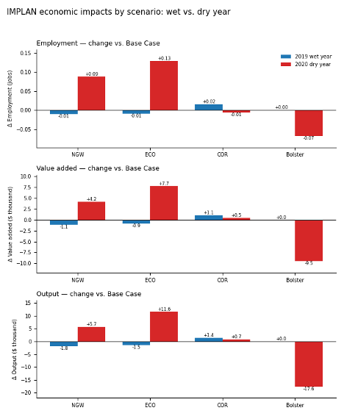

New Green Watershed's land-use conversion is a different scale entirely. As with Gross Revenue, both Direct (jobs tied directly to farming the affected land) and Total (adding IMPLAN's regional multiplier for supporting businesses and household spending) are reported. Direct baseline: about 7,650 Delta ag-tied jobs. Total baseline: about 11,814 jobs.

Restoration level | Direct jobs, adjusted | Direct change | Total jobs, adjusted | Total change
Full MW | approx. 4,400 jobs | approx. –3,250 jobs (–42%) | 6,689 jobs | –5,125 jobs (–43.4%)
0.5MW | approx. 4,720 jobs | approx. –2,930 jobs (–38%) | 7,693 jobs | –4,121 jobs (–34.9%)
0.25MW | approx. 4,850 jobs | approx. –2,800 jobs (–37%) | 8,031 jobs | –3,783 jobs (–32.0%)
Note: Direct figures are an approximation: on rice-converted islands, IMPLAN was not separately rerun for the new rice acreage, so the direct jobs supported by that acreage are estimated using the Delta's existing rice sector's jobs-per-dollar-of-revenue ratio. Both are first-order, preliminary results, and should be revisited once the construction-cost questions elsewhere in this document are settled. For Eco Machine’s land-use footprint, the estimate is 2-8 direct jobs lost (3-12 considering the multiplier effects), depending on how much of the Suisun Marsh is restored.

Metric: Value Added Change

Location of Measurement
Same as Employment: salinity-only pathway Delta-wide and by zone; New Green Watershed's land-use pathway Delta-wide, from the same IMPLAN run; Eco Machine's land-use pathway not yet available. Eco Machine’s land-use pathway estimated as described under Gross Revenue Change above.

Methods
What we are measuring: wages, business income, and taxes generated by Delta farm activity once revenue works its way through the regional economy, via IMPLAN. As with Employment, New Green Watershed's land-use pathway uses Cai et al. IMPLAN run of the adjusted base case.

Results

Adaptation Scenario Analysis
Same pattern as Employment for the four salinity-only scenarios: negligible (on the order of plus or minus a few thousand dollars out of a billion-dollar regional economy).
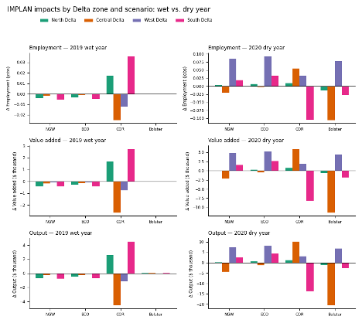

For New Green Watershed's land-use effect, both Direct and Total value added are reported, on the same basis as Gross Revenue and Employment above. Direct baseline: about $671M/yr. Total baseline: about $999M/yr Delta-wide regional value added tied to agriculture.

Restoration level | Direct VA, adjusted | Direct change | Total VA, adjusted | Total change
Full MW | approx. $364M/yr | approx. –$307M/yr (–46%) | $542M/yr | –$458M/yr (–45.8%)
0.5MW | approx. $531M/yr | approx. –$141M/yr (–21%) | $767M/yr | –$232M/yr (–23.3%)
0.25MW | approx. $582M/yr | approx. –$89M/yr (–13%) | $838M/yr | –$162M/yr (–16.2%)
Note: Direct figures use the same rice-sector-ratio approximation for newly-converted rice acreage, validated the same way (reassembling Total from Direct plus the regional multiplier lands within about half a percent of the actual reported Total). Both are first-order and preliminary. For Eco Machine’s land-use footprint, direct value added lost is $0.18-0.70 M/yr total).

Comparative Scenario Performance Ranking
Scenarios are scored on a −5 (worst) to +5 (best) scale, anchored at 0 for Business As Usual, consistent with the other Just Transitions criteria. Because the salinity-only effects are so small relative to the Delta's billion-dollar ag economy, and the land-use effects for New Green Watershed are so large by comparison, this criterion scores each scenario on whichever effect actually dominates for it, rather than forcing every scenario onto one percent-based scale. New Green Watershed's Employment and Value Added scores below reflect Cai et al. IMPLAN run of the land-use pathway; Eco Machine’s score reflects the land-use estimate described under Gross Revenue Change.

Scenario | Dominant effect | Gross Revenue | Employment | Value Added
Business As Usual | baseline | 0 | 0 | 0
Calling on Reserves | salinity (small) | 0 / +1 | 0 / +1 | 0 / +1
Bolster and Fortify | salinity (small) | -1 | -1 | -1
Eco Machine | Land use conversion (little farmland; larger construction costs). | 0 | 0 | 0
New Green Watershed — Full MW | land-use conversion (large) | -5 | -5 | -5
New Green Watershed — 0.5MW | land-use conversion (large) | -4 | -4 | -4
New Green Watershed — 0.25MW | land-use conversion (large) | -3 | -3 | -3
Note: Eco Machine's farm revenue, job and value added losses are at most 0.1% of the Delta BAU, and its salinity effects are slightly positive, so it scores zero on all three metrics. Its construction costs and the potential loss of duck-club activity in Suisun Marsh if any are yet to be quantified.

Implications and Discussion
Pulled together, this criterion tells a two-part story. For three of the six futures — doing nothing, changing reservoir operations, or fortifying levees — the Delta's farm economy barely notices the difference, in dollars, jobs, or regional value added, in either a wet or dry year. That is a genuinely reassuring finding: none of those choices puts the region's agricultural economy at meaningful risk.
New Green Watershed is a different story entirely, and not because of water quality. It converts real, productive farmland to wetland and rice at scale. On a Total (regional) basis, employment falls by about 43% at Full MW, value added by about 46%, and revenue by about 46%; the 0.5MW and 0.25MW levels show smaller but still substantial effects (roughly 35% and 32% for employment; 23% and 16% for value added and 26% and 20% for revenue). On a Direct (on-farm) basis the losses are somewhat smaller in dollar and job terms but a similar story: revenue down 46% at Full MW and down to 19% at 0.25MW, with employment and value added following a similar pattern. Carbon-offset revenue offsets roughly 7-10% of the on-farm revenue loss, more so at lower restoration intensities — a real but partial benefit, not a rescue. This is not a reason to avoid restoration — it is the actual economic tradeoff that restoration entails, and it should be weighed honestly against what the wetlands deliver elsewhere (carbon storage, habitat, flood protection, and possibly recreation are all covered by other parts of this study, not this one).
Eco Machine converts about 14,000–54,000 acres to tidal marsh, but almost none of that land is farmed, so its effect on farm revenue, jobs and value added is very small (at most about $1.2M/yr of farm revenue). Its main economic effects are a one-time construction cost of about $0.85–1.5 billion, carbon-offset revenue of $1.6–5.9M/yr at $15/tCO2e, and the loss of duck-club activity in Suisun Marsh, which is not measured here. Its largest benefits, from the Franks Tract redesign, fall under water supply, water quality and recreation.
● Business As Usual, Calling on Reserves, and Bolster and Fortify: negligible Delta-wide economic effect from salinity alone, in any year.
● New Green Watershed: a large, real cost in farm revenue, jobs, and regional value added from land conversion — roughly 13-46% depending on restoration intensity, metric, and whether Direct or Total effects are counted — only partly offset (roughly 7-10%) by carbon revenue, with ecotourism and the full construction-cost picture still open questions.
● Eco Machine: negligible effect on farm revenue, jobs and value added (score 0), with a one-time construction cost of about $0.85–1.5 billion depending on how much of Suisun Marsh is restored.
● Next steps: confirm restoration extent Suisu Marsh Eco Machine, and potential duck-club impacts, rerun IMPLAN directly on the rice-converted acreage, and decide on ecotourism revenue projections.

References
References
Cai, Y., Milligan, B., Medellín-Azuara, J. et al. "Economic analysis of just land-use transitions in California's Sacramento-San Joaquin Delta." Manuscript in preparation, target journal: Journal of Hydrology: Regional Studies.
California Department of Fish and Wildlife. 2021. Vegetation – Suisun Marsh – 2021 [ds3187]. Sacramento, CA.
California Natural Resources Agency. Hill Slough Tidal Marsh Restoration Project, California EcoRestore project sheet. https://resources.ca.gov/CNRALegacyFiles/docs/ecorestore/projects/Hill_Slough_Tidal_Restoration.pdf
Deverel, S. J., Olds, M., Burt, J. W., Hankins, D., Milligan, B., Kraus-Polk, A., Ohlson, D., Failing, E., Miller, T., & Ryan, R. (in press). Delta Island Adaptations: Development of regenerative land uses for subsided peatlands in the Sacramento–San Joaquin Delta; geospatial analysis of ecosystem, infrastructural and economic factors, and effects. San Francisco Estuary and Watershed Science.
Medellín-Azuara, J., Hanak, E., Howitt, R., & Lund, J. (2012). Transitions for the Delta Economy (p. 62). Public Policy Institute of California. http://www.ppic.org/
UC Davis, California Department of Fish and Wildlife, and California Department of Water Resources. 2020. Franks Tract Futures Reimagined 2020: Final Report. https://franks-tract-futures-ucdavis.hub.arcgis.com/pages/final-report

